QUESTION : 1
Create a table called Orders with columns: order_id, user_id, payment_method, and amount. Insert at least 8 sample records representing different users and payment methods (like UPI, Card, Wallet, COD) :
TABLE Orders :
CREATE TABLE Orders(
order_id INT,
user_id INT,
payment_method VARCHAR(20),
amount DECIMAL(10,2),
PRIMARY KEY(order_id)
);
INSERT INTO Orders(order_id,user_id,payment_method,amount)
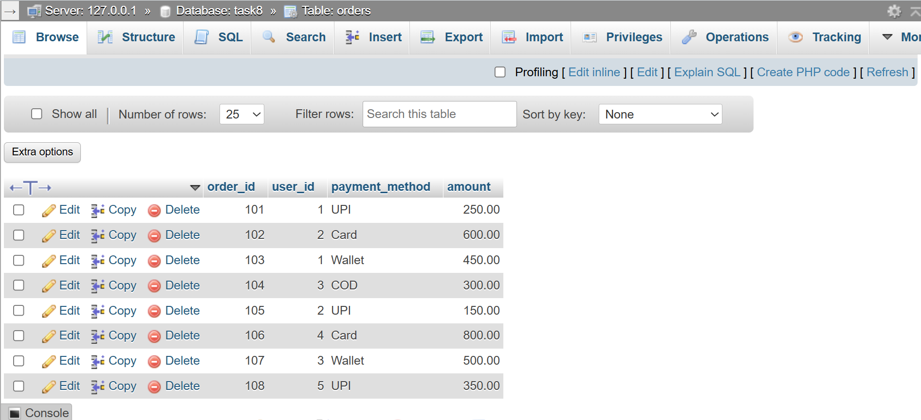
VALUES (101,1,'UPI',250), (102,2,'Card',600), (103,1,'Wallet',450), (104,3,'COD',300), (105,2,'UPI',150), (106,4,'Card',800), (107,3,'Wallet',500),(108,5,'UPI',350) ;
QUESTION : 2
Write an SQL query to count how many orders were placed using each payment_method in the Orders table, similar to how Zomato shows payment breakdown in analytics :

SELECT payment_method, COUNT(*) AS total_orders
FROM Orders GROUP BY payment_method ;
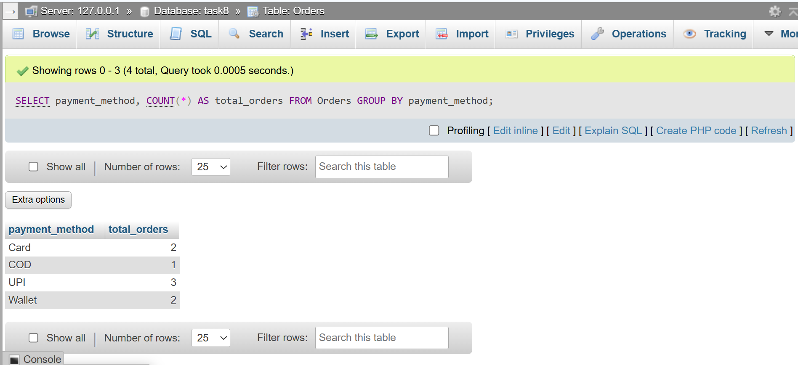

QUESTION : 3
Write an SQL query to find the total amount spent by each user_id in the Orders table. Display user_id and their total spend :

SELECT user_id,SUM(amount) AS total_spend
FROM Orders GROUP BY user_id ;
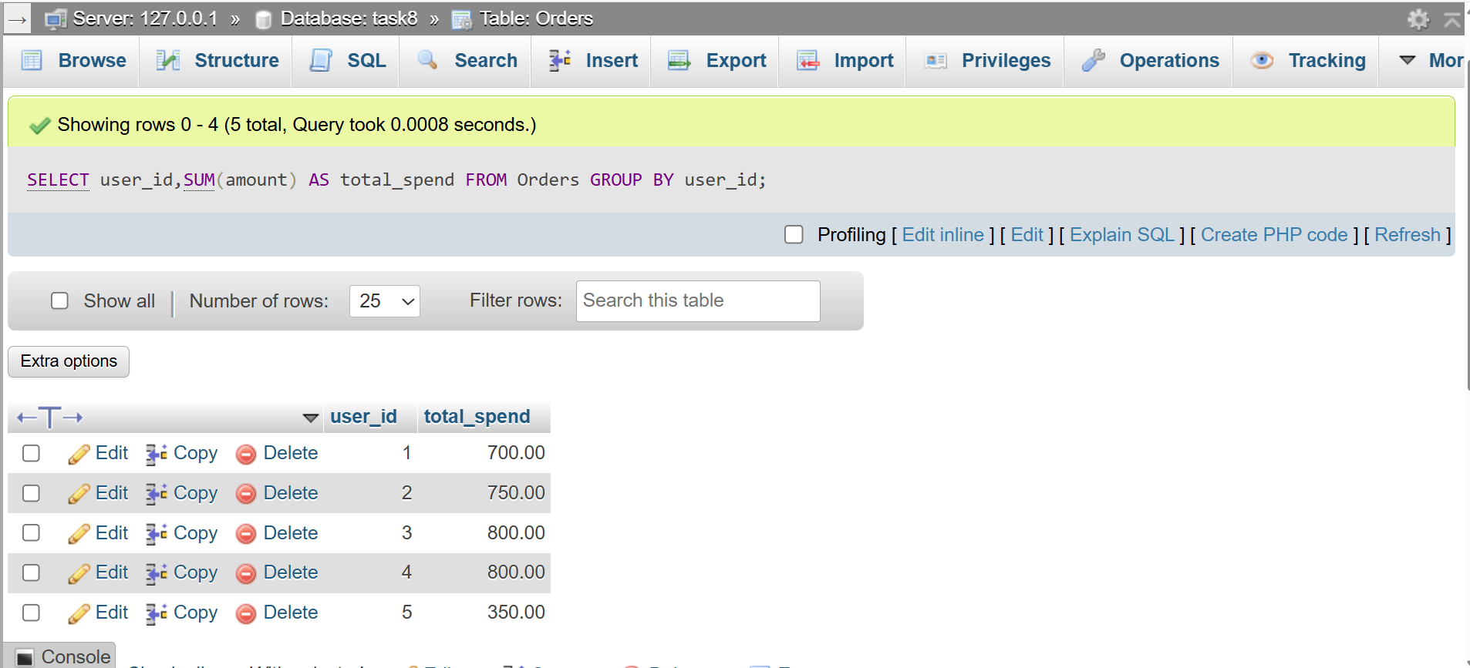
QUESTION : 4
Write an SQL query to show only those payment methods where the average order amount is greater than 300, using GROUP BY and HAVING.<br><br><em><strong>Hint:</strong> Use AVG(amount) in your HAVING clause.</em> :

SELECT payment_method, AVG(amount) AS average_amount
FROM Orders
GROUP BY payment_method HAVING AVG(amount)>300;

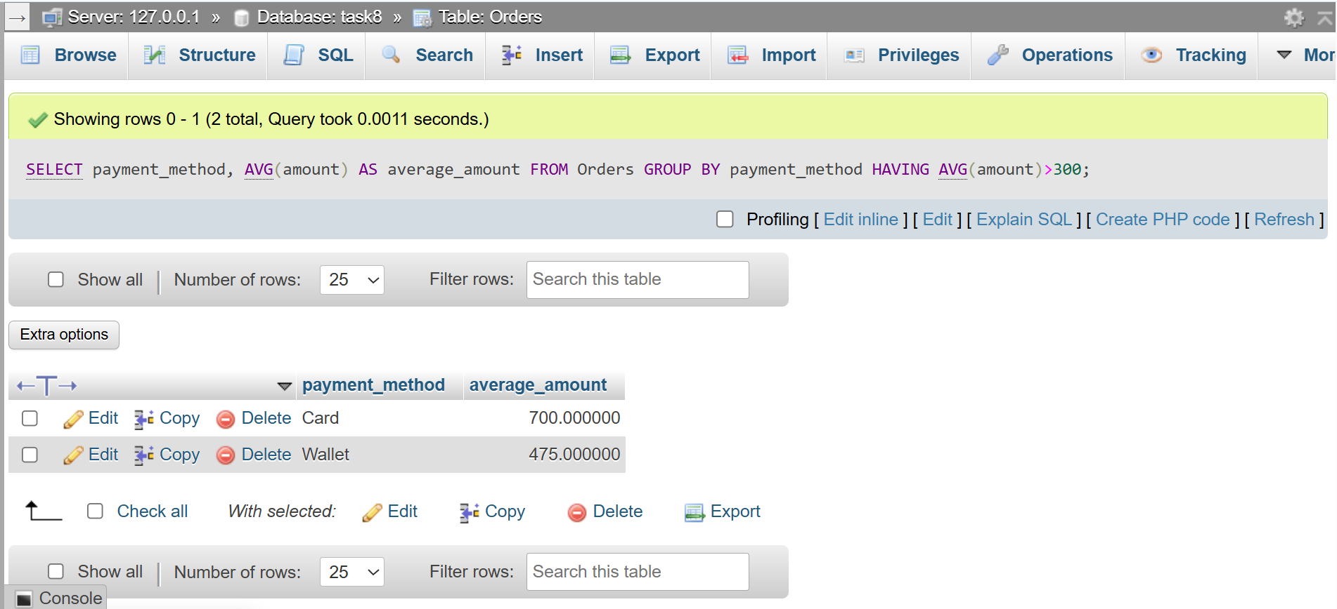
QUESTION : 5
Explain the difference between WHERE and HAVING by giving one example query for each, using the Orders table. Your examples should show a scenario where WHERE and HAVING filter different things :

WHERE Row-level filtering :
SELECT * FROM Orders WHERE amount > 300 ;

HAVING Group-level filtering :
SELECT payment_method, AVG(amount) AS average_amount
FROM Orders
GROUP BY payment_method HAVING AVG(amount)>300;
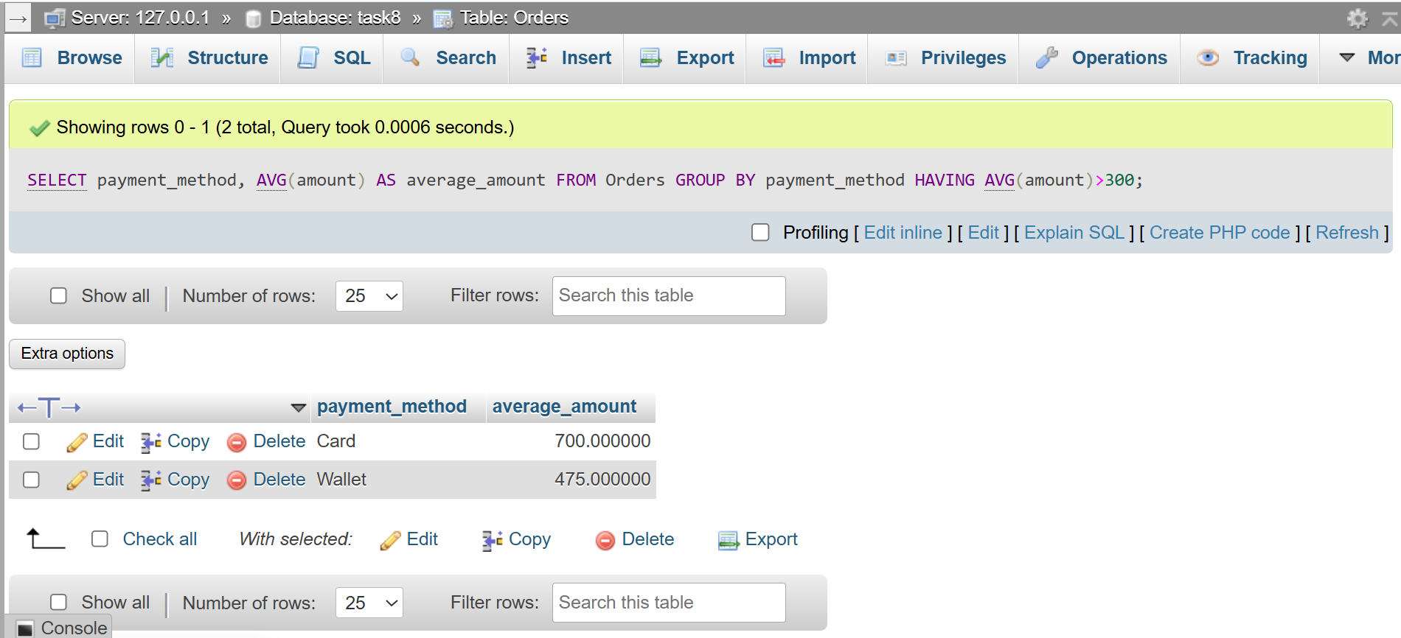
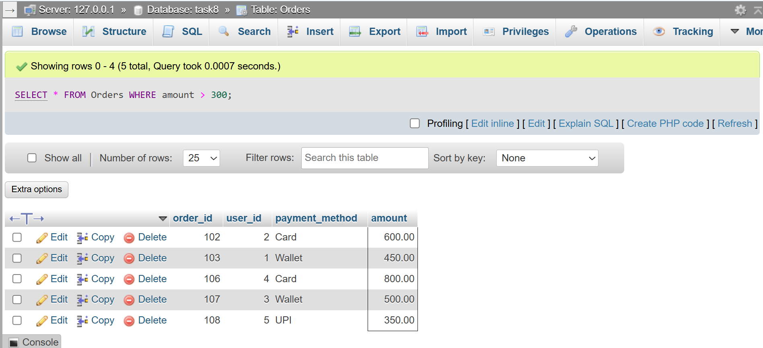
WHERE | HAVING
Filters individual rows before grouping. | Filters groups after GROUP BY.
Executed before the GROUP BY clause. | Executed after the GROUP BY clause.
Cannot use aggregate functions (SUM(), AVG(), COUNT()) directly. | Used with aggregate functions (SUM(), AVG(), COUNT()).
Filters records before calculations are performed. | Filters grouped results after calculations are performed.

